**BioLUC Model Parameters: Comparison of Time Series  
to Existing Literature and Sensitivity Analysis**

Eric Bryant

Office of Science, Science Undergraduate Laboratory Internship Program

University of Massachusetts at Amherst

Amherst, Massachusetts

National Renewable Energy Laboratory

Golden, Colorado

August 9, 2013

Prepared in partial fulfillment of the requirement of the Department of Energy, Office of Science’s Science Undergraduate Laboratory Internship under the direction of Laura Vimmerstedt at the Strategic Energy Analysis Center at the National Renewable Energy Laboratory



Participant:

Research Advisor:

ABSTRACT

BioLUC was a system dynamics model written in Isee Systems Stella™ v9.1.4, initiated 2010, with the purpose of describing how biofuels-related energy policy in individual nations can drive future food supply shortfalls as well as land use allocation world-wide. A key remit for the work described in this paper was to provide exploratory analysis of the recently upgraded BioLUC model, currently running on Stella™ v10. Results were computed for four divergent global socio-economic scenarios, tracing effects of enhanced land area dedicated to biofuels production, and also greater or lesser increases in global per capita gross domestic product (GDP) – as the latter translated into to valid model input parameters, such as propensity toward dietary demand for animal products. Results for these scenarios were analyzed in comparison with a model-based sensitivity analysis. As current, the upgraded BioLUC v10 model weakened the selection methods by which land usage was computed, such that the model demonstrates enhanced sensitivity to the utilization of agricultural land for bioenergy production.

I. INTRODUCTION

Expanding consumption of biofuels within the United States domestic market may provide an opportunity to mitigate the harmful effects of climate change, enhance the short- and long-term security of the domestic energy supply, while at the same help to reduce the importation of foreign petroleum.1 However, early-stage environmental policy analysis on this subject tended principally to center around one benefit, viz. a net reduction in greenhouse gas (GHG) emissions anticipated to result from increased biofuels utilization.2 In contrast, more recent life-cycle assessment (LCA) studies of the subject have considered secondary effects, such as: albedo associated with land surface cover type; or, carbon emissions associated with the various land use changes required to increase biofuels production.3

Increasingly, contemporary research vested in LCA principles factors biofuels demand as a potential driver of agricultural expansion onto previously undeveloped land.4,5 The National Renewable Energy Lab (NREL) developed the simulation model BioLUC to describe the interaction between increased demand for biofuels and land use changes (LUC), and the competition for rural land between natural environment, agricultural, and abandonment uses.6 BioLUC was developed as a finite-difference model used to approximate the solution of various non-linear differential equations, given time series data selected as their input functions. These input time series were specified by region, and included the categories: population, dietary demand associated with that population, biofuels demand and crop yields.

The work described in this paper presents the results of four simulations run in BioLUC. Each of the four simulations was keyed to a scenario describing an independent world socio-economic future, such as those produced by the World Agricultural Organization (FAO) or the United Nation’s Intergovernmental Panel on Climate Change.7,8 An analysis describing behavior of the BioLUC model under variation of input functions as time series was also included, for example crop yields as a measure of spatially-averaged yearly agricultural productivity of land. The sensitivity analysis was intended to indicate the responsiveness of the model to changes in the crop yield curves on a region-by-region basis, as well as to produce similar results for other model input parameters.

II. MODEL AND INPUT DATA DESCRIPTION

A. Model Construction

BioLUC was developed as a global land use simulation model utilizing the Stella™ software package. The Stella™ software provides an internal model logic based upon system dynamics modeling approach, combined with a visual programming environment.9 As of the most recent model version, BioLUC described trends in land use based upon an expanded 19-region discretization of global landmasses.10 Model regions for the expanded BioLUC were based upon global trade analysis project (GTAP) boundaries.11 All regions were modeled similarly, utilizing an identical series of constitutive arithmetic operations, leading to a global finite difference solution at each yearly time step.

However, BioLUC regions differed with respect to assigned parameters, such as the total size of the region, or its initial population and trends in population growth. Each valid permutation of input parameter datum or time series corresponded to a unique global scenario, of which only four are presented in this paper. These scenarios described describing developmentally differentiated, alternative worlds at 2050: Unchanged World (UN), and Changed World (CH). Additionally, both the scenarios UN and CH were assigned variants exhibiting an extreme relative increase in global demand for biofuels. These twinned variants were named Unchanged World-High Biofuels (UN-B) and Changed World-High Biofuels (CH-B).

BioLUC relies upon the Stella™ modeling infrastructure to provide for yearly accounts of the outputs: near natural, pasture, agricultural and abandoned land uses (Table 1), as well as modeling resolutions of internal animal product and crop stocks supply-demand imbalances through import and export activities.6

B. Scenario Data Description

BioLUC scenarios were derived from a review of existing literature, with results presented in Tables 2-5. In these tables, comparison was made between the 19-region model scenarios UN and CH, with the four global food demand and population growth scenarios constructed by the Intergovernmental Panel on Climate Change working group producing the Special Report on Emission Scenarios (IPCC-SRES)8.

Time series data was extrapolated **o**r interpolated to increments of one year, for years 1991-2050 (Figures 1-5). All projections of population growth were notably non-linear.12 Scenario CH followed the IPCC-SRES scenario A1, where applicable data was available. In contrast, UN was based upon projections produced for the Food and Agriculture Organization of the United Nations (FAO).7 FAO yield input parameter time series incorporated projected regional variations in yield associated with climate change. A separate methodology has been proposed to modify a relatively arbitrary time series to account for the results of climate change, however this procedure was not used for the purposes of this paper.13

In contrast to the three other time series variables, biofuels demand was considered an exogenous, policy-driven input parameter. For example, the scenario variants UN-B and CH-B anticipated that by 2050, cellulosic biofuels displace 25% of global gasoline and diesel demand.6 In contrast UN and, less dramatically, CH assume lower levels of growth in biofuel demand. The basis for the description of biofuels demand as ‘exogenous’, however, was simply that independent variation of this parameter was a necessary precondition to examine its effect on outputs like land use, or potential for shortfall in food supply.

Table 1: BioLUC Land Classes and Miscellaneous Terms.

|  |  |  |
| --- | --- | --- |
| Term |  | Definition: |
| Pasture Land Class (v9)* |  | Land used for cow, sheep and goat (red meat product-producing) pasture. Defined as *latent land* in BioLUC v10. Name change indicates lack of 1:1 correlation between: lands developed for purposes of pastoral use, and their actual use for grazing purposes. |
| Latent Land Class (v10)** |  | Demand for pastoral hectares in any v10 time step may be fulfilled as a fraction of total latent land in that region. Land modeled as latent may devolve to *near pristine* class land after a period of time, wherein there is no requirement for its use as pasture. |
| Available Land Class (v9) |  | Represents sum total of forests and grasslands in region. In v10, available land class was bifurcated into the *set aside* and *near pristine* land classes, in order to similarly dichotomize, respectively, inelastic and elastic conversion curves. |
| Shortfall in Dietary Demand |  | Mechanism to describe shortfall of food production with respect to demand in a region. Whereas BioLUC was constructed to be agnostic to economic functions like functions connecting shortfalls to price variation, a shortfall in any time period suggests likelihood of price increases for that product. |

* BioLUC v9 was developed to model two regions, USA and rest of world (ROW).

** BioLUC v10 introduced the 19-Region model, and complexified land processes described above.

Table 2: Developed and Developing Regions.

|  |  |  |
| --- | --- | --- |
| Developed |  | Developing |
| Canada  East Asia  European Union 27-Country Region  Japan  Oceania  Rest of Europe  USA |  | Brazil  Central America north of Brazil  China & Hong Kong  India  Malaysia & Indonesia  Middle East & North Africa  Rest of Central Europe  Rest of South Asia  Rest of South East Asia  Russia  South America south of Brazil  Sub-Saharan Africa |
|  |

Table 3: Data & Sources for Dietary Demand Input Parameter Time Series.

|  |  |  |  |  |  |
| --- | --- | --- | --- | --- | --- |
| Name of Time Series | Associated Scenario | | | Source | Extrapolation Method or Justification of Modification from Source |
| IPCC- SRES8 | NREL  2-Region  Model6 | NREL  19-Region Model |
| Base | B1, B2 | BAU, HB | UN,UN-B | FAO7 | - |
| High | A1, A2 | HF, HFB | CH,CH-B | Curve relating demand to per-capita GDP.14 |

Table 4: Data & Sources for Population Growth Input Parameter Time Series.

|  |  |  |  |  |  |
| --- | --- | --- | --- | --- | --- |
| Name of Time Series | Associated Scenario | | | Source | Extrapolation Method or Justification of Modification from Source |
| IPCC- SRES8 | NREL  2-Region  Model6 | NREL  19-Region Model |
| Low | A1, B1 | - | CH,CH-B | United Nations12 | - |
| Base | B2 | BAU, HB, HF, HFB | UN,UN-B | - |
| High | A2 | - | - | - |

Table 5: Data & Sources for Biofuels Demand Input Parameter Time Series.

|  |  |  |  |  |  |
| --- | --- | --- | --- | --- | --- |
| Name of Time Series | Associated Scenario | | | Source | Extrapolation Method or Justification of Modification from Source |
| IPCC- SRES8 | NREL  2-Region  Model6 | NREL  19-Region Model |
| None | - | - | - | - | Zero biofuels demand in future years. |
| 2014*** | - | BAU, HF | UN | FAO7 | Extant biofuels policies are met through 2014. |
| 10% | - | - | CH* | NREL6 | Biofuels demand computed as step-wise fractions of yearly gasoline demand. |
| 15% | - | - | - |
| 20% | - | - | - |
| 25% | - | HB, HFB | UN-B,  CH-B** |

* CH is intended to map IPCC-SRES scenario A1B. ** CH-B maps IPCC-SRES scenario A1T.

*** See Table 11, panel on UN.

Table 6: Data & Sources for Yield Input Parameter Time Series.

|  |  |  |  |  |  |
| --- | --- | --- | --- | --- | --- |
| Name of Time Series | Associated Scenario | | | Source | Extrapolation Method or Justification of Modification from Source |
| IPCC- SRES8 | NREL  2-Region  Model6 | NREL  19-Region Model |
| Low | - | - | - | - | No growth in yield beyond 2010. |
| Base | - | BAU, HB, HF, HFB | CH,CH-B | FAOSTAT and GTAP15,16 | Extrapolated linear regression. |
| High | - | - | - | Oak Ridge17 | - |
| FAO | - | - | UN,UN-B | FAO7 | Data set specifies only a subset of yields. |

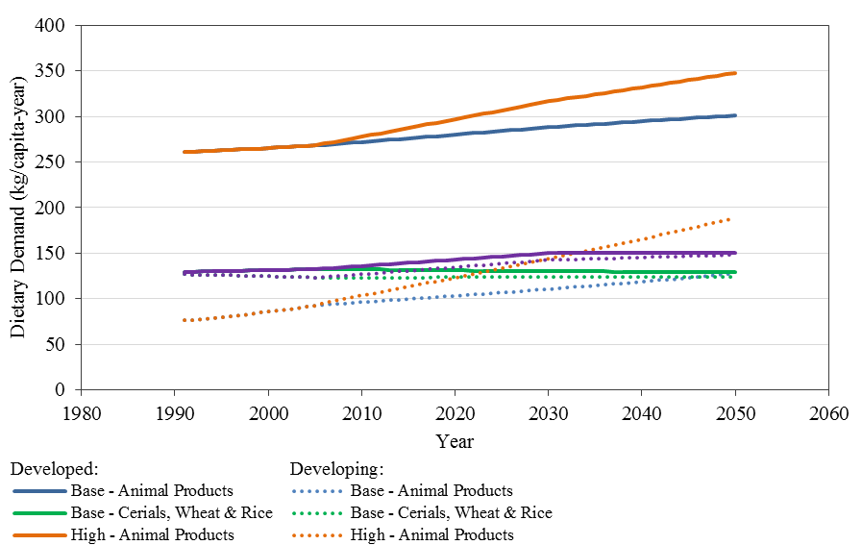

FIG. 1. Average yearly dietary demands, in developing and developed regions as per Table 2, showing Base and High time series described in Table 3.

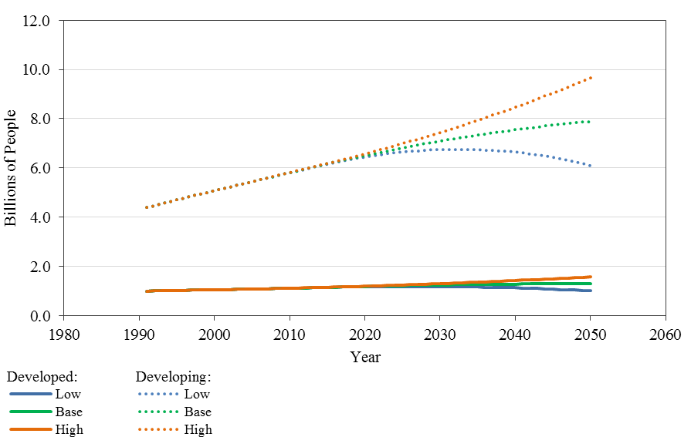

FIG. 2. Aggregate population in developing and developed regions, showing Low,   
Base and High time series described in Table 4.

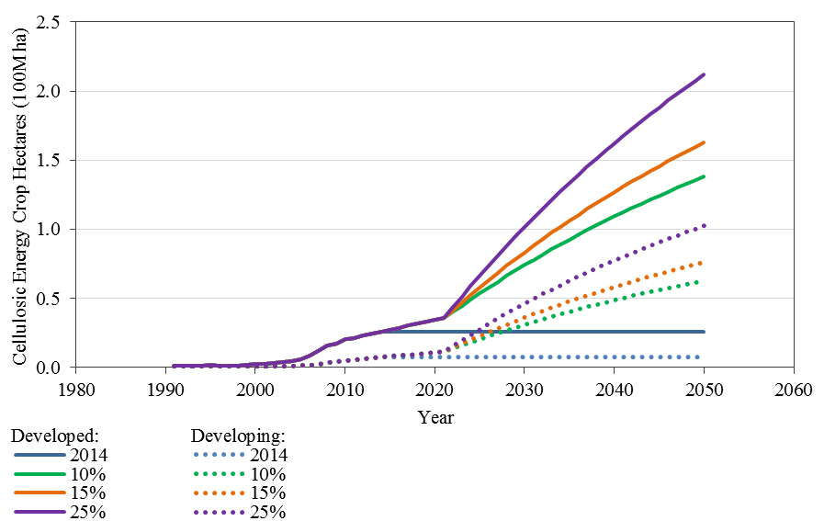

FIG. 3. Aggregate yearly crop land allocated to energy crops in developing and   
developed regions, showing Base and High time series described in Table 5.

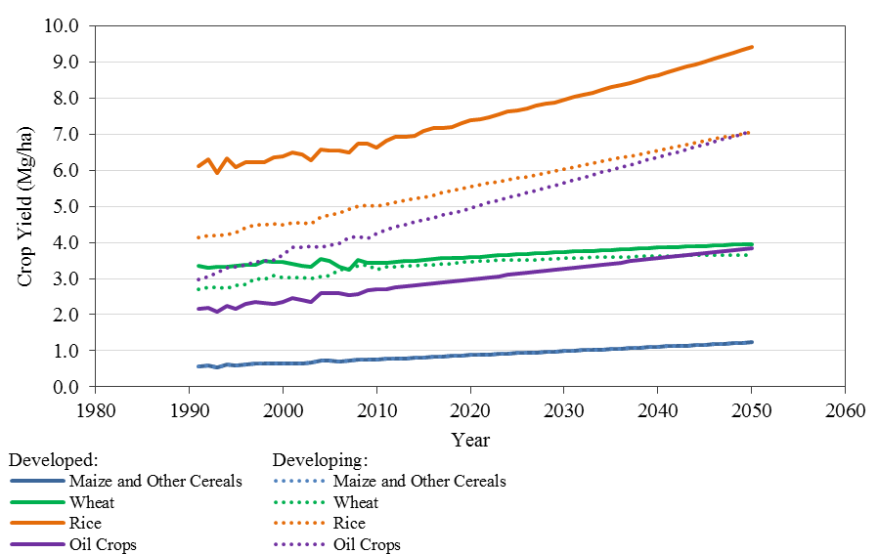

FIG. 4. Average scenario crop yields in developing and developed regions, showing   
Base time series for cereals, wheat, rice and oil crops described in Table 6.

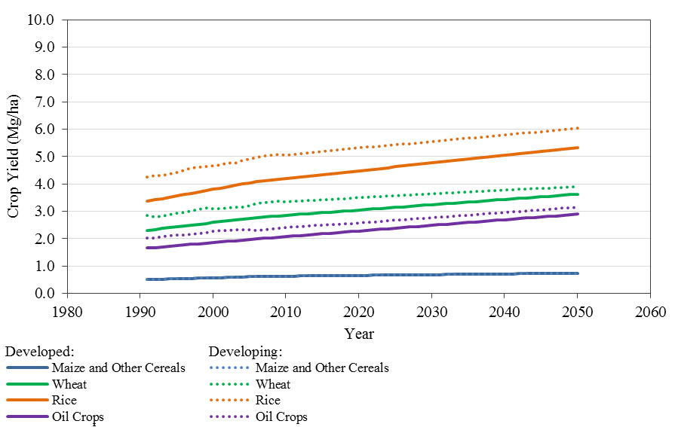

FIG. 5. Average scenario crop yields in developing and developed regions, showing   
FAO time series for cereals, wheat, rice, and oil crops described in Table 6.

C. Construction of Input Data Time Series for Sensitivity Analysis

A model-based sensitivity analysis was constructed for BioLUC. The objective was to ascertain trends in the behavior of selected model output variables, subjected to variation in the input time series parameters. Varied input time series parameters included: yield, mix of red meat and poultry products in diet, and biofuels demand, for years between 2010 and 2050. Initially, for all crops under consideration, low and high yield curves were established for each region . These curves were identified as and , respectively:

(1)

Maximum yield growth rates were based upon the maximum anticipated exponential growth rate for the ‘High’ yield input parameter time series (Table 6). The initial growth rate was the maximum growth rate anticipated between years 2010 to 2030, with rounding to the nearest 0.5%, and ultimate maximum growth rate based on years between 2030 and 2050 (Table 7). For any crop in all varied regions and every year , yield was capped in absolute terms at 2.50 the value of USA yield in that year, multiplied by the ratio of the region’s 2010 yield normalized by the USA 2010 value.

Table 7: Sensitivity Analysis Crop Yield Growth Rates.

|  |  |  |  |  |
| --- | --- | --- | --- | --- |
| Region Group | Growth Rate (%) | | | |
| Years 2010-2030 | | Years 2030-2050 | |
| Maximum | Minimum | Maximum | Minimum |
| China | 2.5 | 0.0 | 2.0 | 0.0 |
| India | 4.5 | -0.5 | 4.5 | -0.5 |
| Latin America | 4.0 | -0.5 | 3.5 | 0.0 |
| Middle East  and North Africa | 3.5 | -0.5 | 3.5 | 0.0 |
| Russia | 5.5 | -0.5 | 5.5 | -0.5 |
| South East Asia | 3.5 | 0.0 | 3.5 | 0.0 |
| Sub-Saharan Africa | 2.5 | -0.5 | 2.5 | -0.5 |

This ‘cap’ rule was implemented to limit the high yield curves’ otherwise exponential growth. The normalization entailed in the cap was intended to allow for inter-region variability as to the maximum potential crop yield of a region – thus, imposed variability was emplaced to mimic patterns observed in the historical data sets, ascribed to be a result of: differences in climate; availability of water supply; or, other similarly local factors. For example, Central American wheat yields both started and, by extrapolated linear interpretation, continued to trend higher than USA yields in 2014 and onward (Figure 6).

Minimum yield growth rates and originated from the ‘Low’ time series (Table 6), with the values of rates and computed similarly to the maximum growth rates described above (Table 7). The low yield curve was identically formulated as the high yield curve , however without any absolute minimum limit on yields, and with computed for most regions to be valued at 0.0% in years 2030-2050.

Red meat and poultry demand curves shared the same region groups as did the variation of crop yields. Initially, the total combined red meat and poultry demand was described by the ‘Base’ food demand input parameter time series (Table 3). Relative weight ascribed to either red meat or poultry demand was based on their maximum and minimum anticipated ratios, for the time periods 2010 to 2030 and then 2030 to 2050, for any region in the 19-region model (Table 8). High demand curves for red meat and poultry consumption therefore represented the numerically highest fraction of combined demand for either of the animal products.

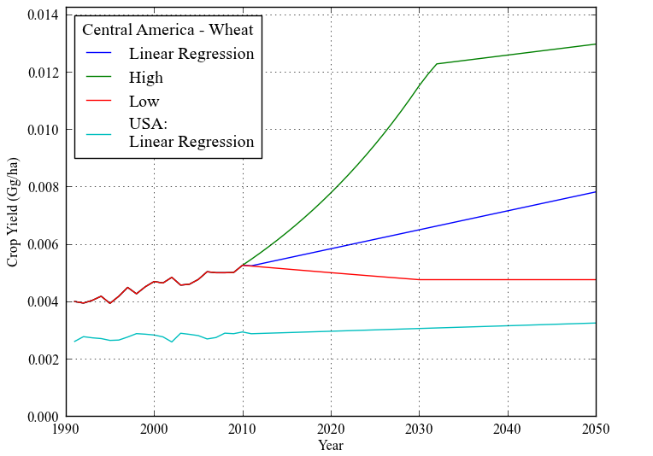

FIG. 6. Central American wheat yields extrapolated over years   
2010-2050, with plot including high curve , low curve ,   
and linear regressions for both Central America and USA regions,   
resulting from extrapolation of historical data for years 1999-2014.

Both minimum and maximum red meat demand curves, and , were described as piecewise linear functions over the ranges: years 2010 to 2030, and then 2031 to 2050:

(2)

Table 8: Sensitivity Analysis Fractional Red Meat and Poultry Product Dietary Demand.

|  |  |  |  |  |
| --- | --- | --- | --- | --- |
| Animal Product | Fraction of Combined Dietary Demand (%) | | | |
| Years 2010-2030 | | Years 2030-2050 | |
| Maximum | Minimum | Maximum | Minimum |
| Red Meat:  Includes Cow, Sheep  & Goat Products | 50 | 35 | 50 | 25 |
| Poultry | 65 | 50 | 75 | 50 |

Constant slopes and were chosen such that each curve achieves the respective minimum or maximum percent red meat consumption by 2030, and then by 2050 (as presented in Table 8); implicitly the time step with respect to Eq. (2) was one year. Low red meat curve was computed identically, using slopes and . Consequently, all produced curves were similar to that exhibited in Figure 7.

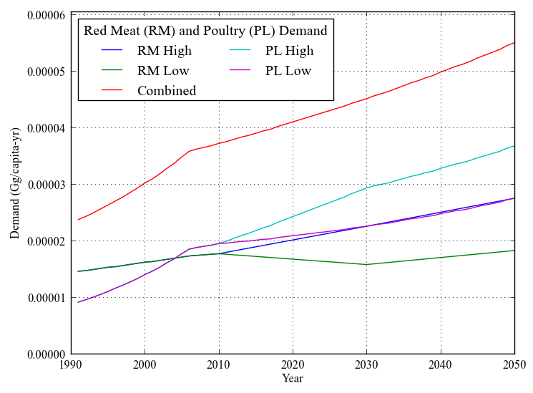

FIG. 7. Central American red meat and poultry demand extrapolated   
over years 2010-2050, showing that the low poultry and high red   
meat curves, as well as low red meat and high poultry  
, sum to the combined demand curve .

As with the combined red meat and poultry demand curve, both low and high biofuels demand curves and were extracted from existing data sets. These curves exactly match the ‘2014’ and ‘25%’ biofuels demand input time series (Table 5, displayed in Figure 3).

A sensitivity analysis framework was constructed, written in Python v2.7.3, using Pandas data analysis module v0.12. Individual yield functions were established for the number of runs in sensitivity study, for each Monte Carlo simulation .

(3)

,

As implied by Eq. (3), for each region within that region’s group, crop yields were computed using an identically valued term. Red meat animal product demand was:

(4)

Red meat and poultry demand curves were zero-sum with respect to the combined animal products curve, consequently:

(5)

,

Biofuels regions were distinctively constituted using a one-to-one correspondence between biofuels region and biofuels region group .

(6)

,

.

III. ANALYTIC OUTPUT

A. Results for IPCC-SRES, FAO and Modified FAO Scenarios

Results for all four scenarios CH, CH-B, UN and UN-B displayed little variation with respect to 2030 land use allocations in any region composed of developed nations, as run on BioLUC v9. These regions include: the USA, Canada, the European Union 27-country region, and Oceana (Figure 8). In particular, output parameters for coupled scenarios CH and CH-B showed only marginal variation. Though to a lesser extent, the same held for scenarios UN and UN-B.

As run on BioLUC v9, with respect to developing regions in the southern hemisphere, distinct differentiation between total crop land usage began to emerge distinctly by 2030. Using UN as a baseline compared to CH: pasture land usage was seen to decrease in favor of increases in total crop land, in both Sub-Saharan Africa and the South American countries south of Brazil; in contrast, Brazilian total available land and total pasture land both increased, to the detriment of the two other categories.

BioLUC v10 results for global and sample regional results of scenario UN normalized by UN-B, as well as CH normalized by CH-B, are also presented (Figures 9-10). Our results broadly indicate drops in the latent land class corresponding to the initial ramping-up of biofuels production. In contrast, cyclical peaks of demand shortfalls for all types of animal products are observed during this period in UN-B (years 2018-2030, Figure 11). Local conditions are critical with respect to the time at which shortfall reaches peak (Figure 12).

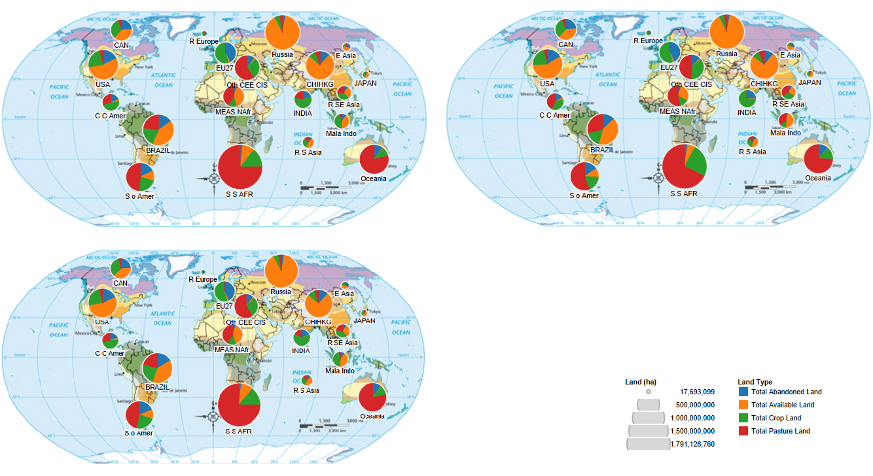

FIG. 8. Counterclockwise from upper left: results for UN, UN-B, and CH scenarios at 2030 run on BioLUC v9, with scenario CH-B having displayed only marginal variation from CH.

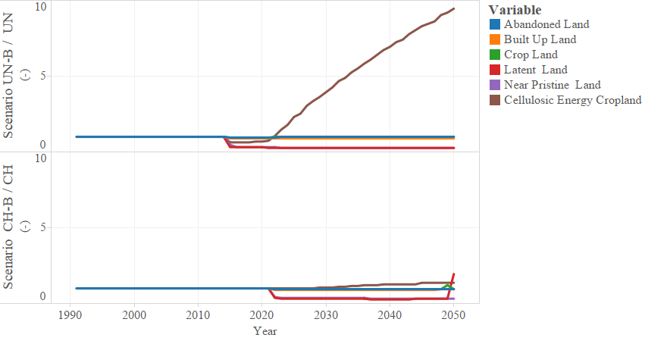FIG. 9. Normalized global land use, run in BioLUC v10 (UN-B / UN and CH-B / CH).

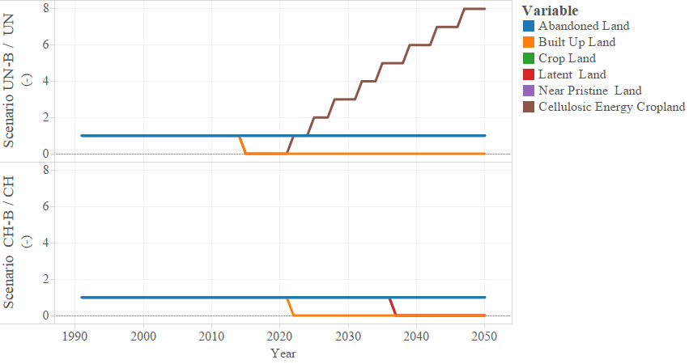FIG. 10. Normalized Central American land use, run in BioLUC v10 (UN-B / UN   
and CH-B / CH).

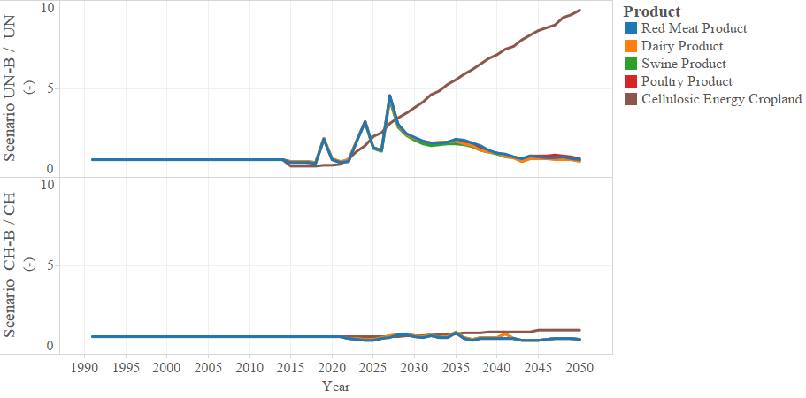FIG. 11. Normalized global food shortfalls, run in BioLUC v10 (UN-B / UN and CH-B / CH).

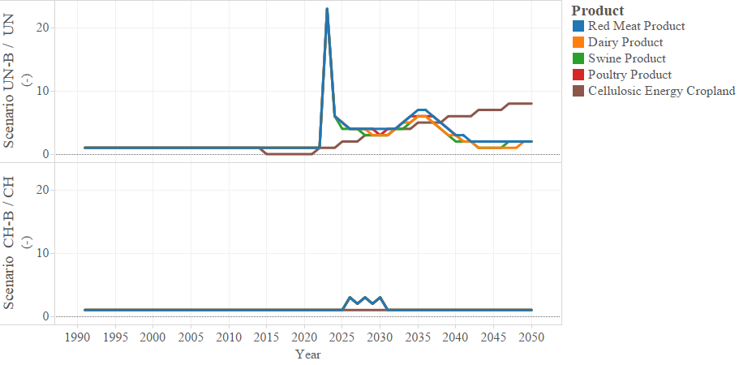FIG. 12. Normalized Central American food shortfalls, run in BioLUC v10 (UN-B / UN   
and CH-B / CH).

B. Sensitivity Analysis using Monte Carlo Simulation

As a consequence of the experimental design, any unique Monte Carlo run was defined uniquely by: two seven-element vectors and ; and, one four-element vector (Table 9). As an intermediary step, dichotomous boundary case results were produced to justify continued investigation using the sensitivity analysis method. Specifically, the two boundary scenarios were described by , , and all singly valued as zeros, the ‘Zeros’ scenario, and then as unity, or ‘Ones’ scenario, were included (Figure 13).

With respect to validity of experimental design, all region groups varied according to and were identical to, or a subdivision of, an inter-country region group also established within FAO’s global agricultural analysis (see Figure 14 and Figure 15 – other parameters modulated by a random variable would be subject to like variation).7 These differentiated results formed the basis authorizing the sensitivity analysis for shortfalls in red meat demand in developing regions (Table 10 – as well as Figure 16, on which each run matches in color the runs presented in Figures 14 and 15).

BioLUC v10 displayed a universal propensity to maximize built-up land use in select regions: Central America, Oceana, East Asia, and the European Union. This result coincided with minimizing available crop land, observable in the middle panels of Figure 16 (Central America) but not Figure 17 (Sub-Saharan Africa).

Table 9: Sensitivity Analysis Region Groups.

|  |  |  |  |
| --- | --- | --- | --- |
| Crop Yield ()  and Animal Product () | | Biofuels Demand  (**)** | |
| Name of  Region | Membership | Name of  Region | Membership |
| China | China & Hong Kong | Brazil | Brazil |
| India | India | China | China & Hong Kong |
| Latin America | Central and South America | European Union | European Union  27-country region |
| Middle East  and North Africa | Middle East  and North Africa | USA | United States of America |
| Russia | Russia |  |  |
| South East Asia | Malaysia, Indonesia, and rest of South East Asia |  |  |
| Sub-Saharan Africa | All Sub-Saharan Africa |  |  |

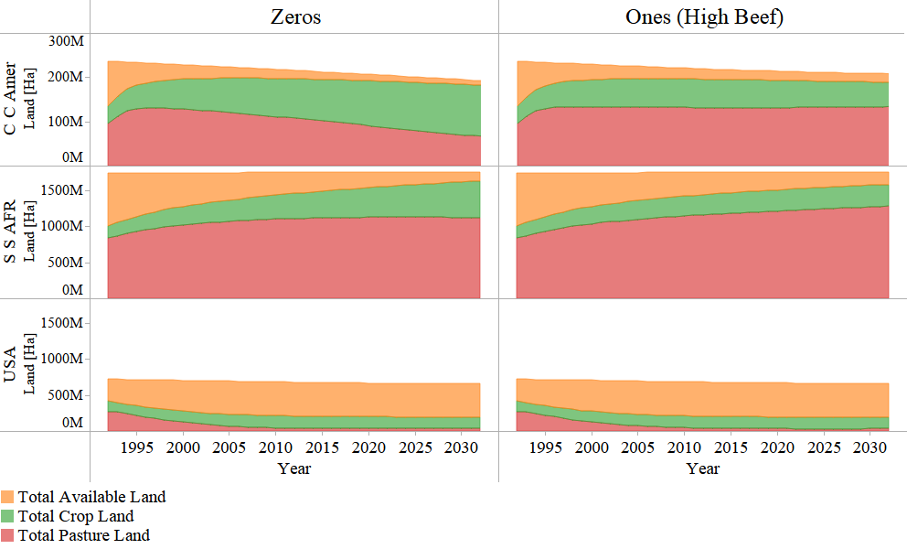

FIG. 13. Land use over time in Zeros and Ones scenarios, a preliminary result run on BioLUC v9.

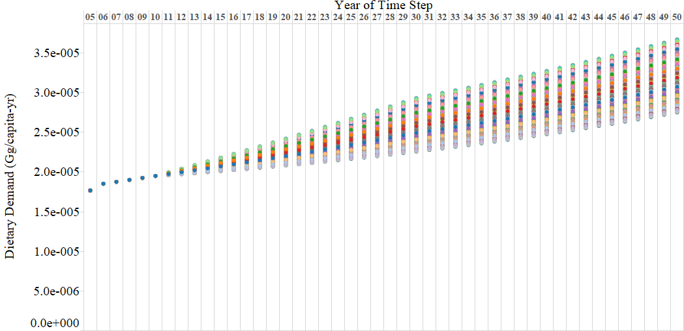

FIG. 14. Central American poultry product dietary demand for: years 2005-2050 and 1,000 Monte Carlo simulations (compare against high and low poultry demand curves, see Figure 7).

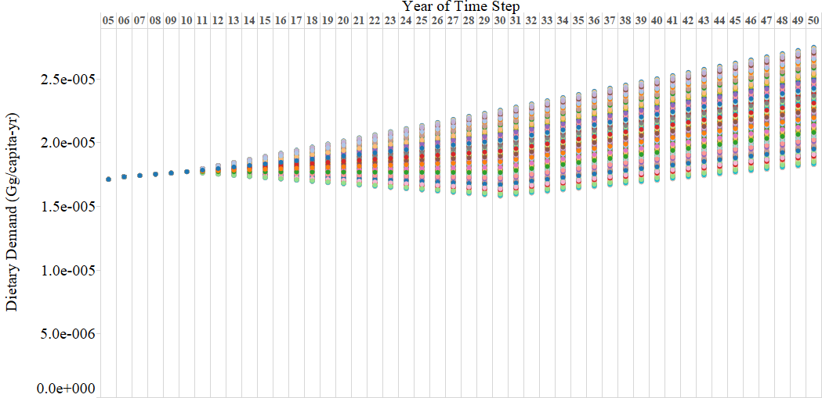

FIG. 15. Central American red meat products dietary demand for years 2005-2050 and 1,000 Monte Carlo simulations; colored dots invert with respect to Figure 14, as red meat and poultry products sum to combined curve for each simulation.

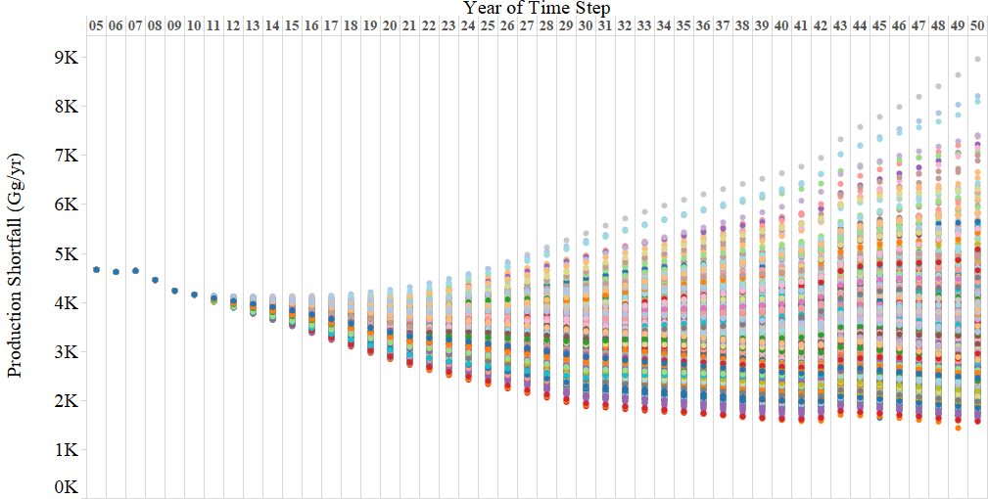

FIG. 16. Central American red meat products shortfall for years 2005-2050 and 1,000 Monte Carlo simulations.

Table 10: Crop Yield Variation and Shortfalls in Animal Production 2030-2050.

|  |  |  |  |  |  |
| --- | --- | --- | --- | --- | --- |
| Name of  Region |  | Product |  |  | Mean of 1,000 Runs (Gg/yr) |
| Brazil |  | Red Meat (RM) | 0.786 | 0.745 | 668.897 |
|  | Poultry (PL) | 0.785 | 0.755 | 895.903 |
| Central America |  | RM | 0.605 | 0.276 | 3158.645 |
|  | PL | 0.592 | 0.425 | 3327.087 |
| China |  | RM | 0.375 | 0.023 | 1723.491 |
|  | PL | 0.368 | 0.023 | 1621.736 |
| India |  | RM | 0.824 | 0.181 | 599.290 |
|  | PL | 0.855 | 0.246 | 298.894 |
| Malaysia and Indonesia |  | RM | 0.199 | 0.081 | 1161.876 |
|  | PL | 0.131 | 0.086 | 1240.190 |
| Middle East  and North Africa |  | RM | 0.839 | 0.858 | 0.829 |
|  | PL | 0.905 | 0.868 | 1.057 |
| Rest of South East Asia |  | RM | 0.898 | 1.023 | 40.934 |
|  | PL | 0.926 | 1.027 | 52.060 |
| Russia |  | RM | 0.671 | 0.753 | 25.112 |
|  | PL | 0.722 | 0.788 | 30.427 |
| South America south of Brazil |  | RM | 0.612 | 0.268 | 3433.045 |
|  | PL | 0.592 | 0.418 | 3648.540 |
| Sub-Saharan Africa |  | RM | 0.751 | 0.947 | 427.101 |
|  | PL | 0.803 | 0.982 | 537.565 |

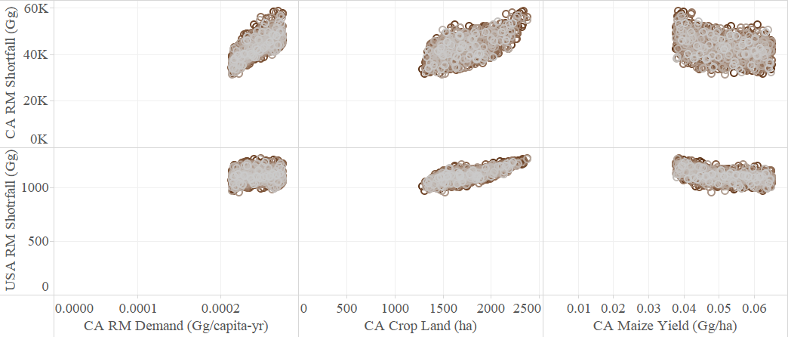

FIG. 17. Central American (CA) and USA red meat (RM) shortfalls in dietary demand for years 2018-2050 and 1,000 Monte Carlo simulations, with each marker one run-year.

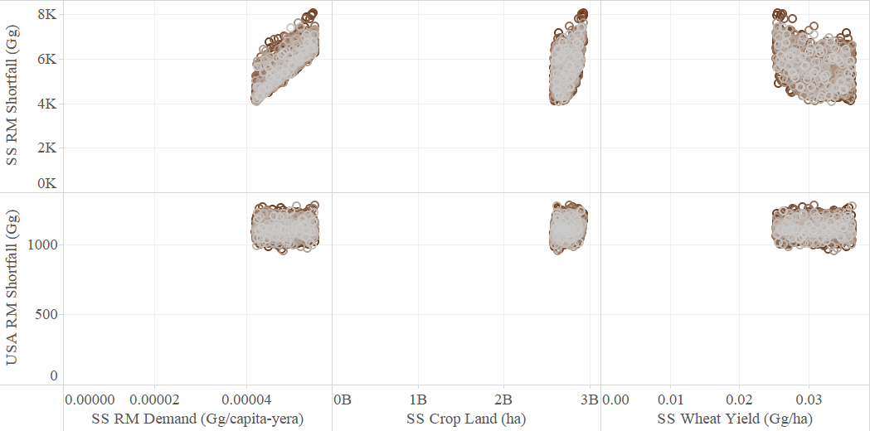

FIG. 18. Sub-Saharan African (SS) and USA red meat (RM) shortfalls in dietary demand for years 2018-2050 and 1,000 Monte Carlo simulations, with each marker one run-year; note that Sub-Saharan crop land develops to billions of hectares by 2018.

IV. DISCUSSION

A. IPCC-SRES, FAO and Modified FAO Scenarios

Analytic comparison of contrasts between UN and CH results was limited, in the sense that GDP growth produces contrary phenomenon with respect to both land use and production shortfalls. In particular, UN and CH represent incompletely opposing world socio-economic trends. For UN, increases in world population were higher; in contrast, CH anticipated a relatively low population but also higher global food demands per capita.

Differentiation as to distinctness or divergence of trends for UN and CH, as well as UN against UN-B, and CH and CH-B, is presented in attached appendices (Appendix A and Appendix B, and Figures 8-12). These loosely quantified comparisons were usefully supplemented by a parameterization, such as may describe relative outputs given results for an entire field of input time series curves: a sensitivity analysis.

B. Sensitivity Analysis

As of time of writing, the framework of the BioLUC sensitivity analysis had been completed. Work was ongoing on processing results for constitutive matrixes of random numbers , , and ,in order to robustly describe many different variations in the possible input parameter time series, as well as combinations of these series.

Particularly of interest, all 20,004 simulations show an unknown model-internal driver forcing built-up land class selection in the following regions: Central America, Oceana, East Asia, and the European Union. The cause of this effect was unknown but constant between all runs. If this selection preference coincided with a significant ramping-up of biofuels demand (during the critical period 2018-2030 for scenario UN-B), there resulted a one-time instance of peaked animal product shortfall in that region (cf. Figure 12), which when combined superimposed to result in asynchronous global peaks (Figure 11).

Sample sensitivity analysis results are presented for animal product shortfalls with respect to crop yields (Table 10); however, computable results are now limited only by number of combinations of inputs output time series. Where efforts were made to reduce rounding errors associated with computations, results showed dramatic improvement. However, these results still implicate the persistence of errors where, for example, exceeds unity. Also, to help others performing similar analysis of Stella™ models in Python, example methods to load and write valid BioLUC input files to and from a Pandas Dataframe object are attached (Appendix C).

V. ACKNOWLEDGEMENTS

This work was funded by a United States Department of Energy Office of Science Summer Undergraduate Laboratory Internship, and administered by the National Renewable Energy Laboratory. Special thanks to my mentor Laura Vimmerstedt, as well as Danny Inman and Ethan Warner. I am particularly indebted to Brian Bush for assistance with work related: to parallel computing in the Windows environment; model-based sensitivity analysis; and, without whose invaluable skillset the results of about 4 BioLUC model runs – and not 20,004 runs – would be presented herein.

REFERENCES

1 A. Demirbas, Applied Energy **86**, S108 (2009).

2 E. Gnansounou, a Dauriat, J. Villegas, and L. Panichelli, Bioresource Technology **100**, 4919 (2009).

3 F. Cherubini, R.M. Bright, and A.H. Strømman, Environmental Research Letters **7**, 045902 (2012).

4 J. Fargione, J. Hill, D. Tilman, S. Polasky, and P. Hawthorne, Science (New York, N.Y.) **319**, 1235 (2008).

5 T. Searchinger, R. Heimlich, R. a Houghton, F. Dong, A. Elobeid, J. Fabiosa, S. Tokgoz, D. Hayes, and T.-H. Yu, Science (New York, N.Y.) **319**, 1238 (2008).

6 E. Warner, D. Inman, B. Kunstman, B. Bush, L. Vimmerstedt, S. Peterson, J. Macknick, and Y. Zhang, Environmental Research Letters **8**, 015003 (2013).

7 N. Alexandratos and J. Bruinsma, *World Agriculture Towards 2030/2050: The 2012 Revision* (2012).

8 N. Nakicenovic, J. Alcamo, and G. Davis, *Special Report on Emission Scenarios (SRES) . A Special Report of Working Group III of the Intergovernmental Panel on Climate Change. Cambridge:* (Cambridge University Press, Cambridge, 2000), p. 595.

9 B.M. Richmond, in *Proceedings of the 1985 International Conference of the System Dynamics Society: 1985 International System Dynamics Conference* (1985), pp. 706–718.

10 B. Bush, D. Inman, S. Peterson, L. Vimmerstedt, and E. Warner, *Milestone Report: LUC Model Expansion to 19 Global Regions* (Golden, CO, 2013), p. 7.

11 R. Keeney and T.W. Hertel, American Journal of Agricultural Economics **91**, 895 (2009).

12 United Nations, *World Population Prospects The 2010 Revision* (2011).

13 M.. Parry, C. Rosenzweig, a Iglesias, M. Livermore, and G. Fischer, Global Environmental Change **14**, 53 (2004).

14 D. Tilman, C. Balzer, J. Hill, and B.L. Befort, Proceedings of the National Academy of Sciences of the United States of America **108**, 20260 (2011).

15 Food and Agriculture Organization of the United Nations, Statistical Database (2012).

16 A. Aguiar, R. McDougall, and B. Narayanan, Center for Global Trade Analysis, Purdue University (2012).

17 G. Oladosu, K. Kline, P. Leiby, R. Uria-martinez, M. Davis, and M. Downing, **3**, 703 (2014).

Appendix A: Inter-Scenario Fact and Response Sheet.

|  |  |  |  |  |
| --- | --- | --- | --- | --- |
| Baseline Scenarios |  | Divergence(s) Between Scenarios and From Source |  | Comparison |
| UN |  | The FAO scenario projections (Alexandratos and Bruinsma) initiated consideration of anticipated future food demand per captita by analysis of projected increases and decreases in regional gross GDP, projected to grow globally 2.1 percent annually between 2007-2050, and at 3.6 percent in developing countries.  Therefore, Alexandratos and Bruinsma considered such differential growth rates, as would altogether contribute to an approximate halving the ratio of income discrepancy between developed and developing nations by 2050 (unpublished data shared by World Bank, FAO Report Table 2.47).  This economic convergence – not adjusted for in the sensitivity analysis’ input parameter time series – implies with respect to UN results, for example, an increasing equality of dietary demand between developed and developing regions.  Given the construction of the sensitivity analysis presented in this paper, however, impacts of degree of this convergence could be readily be tested for. This analysis would require only random variable-based combination of established high and low dietary demand and population curves, such as displayed in Figures 1 and 2, and the utilization of the same combination methods described in above sections. |  | Variable projections of intra-regional gross domestic product (GDP), and thus disparate increases in food consumption, regarding the demand for animal products in both developed and developing worlds, are crucial to the distinction between UN and CH.  In both UN and CH, crop yields increased linearly with time, although starting from respectively lower and higher baselines. In UN, no upward asymptote was placed on population growth, and with global population reached 9.2 billion persons by 2050. Consequently, these increases corresponded better with the IPCC-SRES B2 family of scenarios, and were a hallmark of differentiation from CH.  From comparison of the baseline-normalized scenario results (UN-B / UN and CH-B / CH on BioLUC v10), the initial ramping-up period of biofuels demand, years 2018-2030, or the more inclusive range 2010-2030, was critical in understanding the impacts of global biofuels policy on unmet animal products demand in BioLUC v10.  This analysis may be especially important for shortfalls in dietary demand, if FAO projections as to world population growth, as well as conclusions implied by regional GDP growth such as dietary demand, continue to hold (see scenario UN-B / UN in Figure 11). |
| CH |  | Per CH, global population has already reached a maximum by 2030 at 7.9 billion persons. The limit and subsequent reduction of global populations was coupled with increased GDP and therefore consumption of dietary animal products, which are escalated symmetrically in both developed and developing worlds.  Computed FAOSTAT and GTAP projections were notably more optimistic than Alexandratos and Bruinsma regarding current, and thus linearly interpolated future, crop yields. The divergence was marked as pertains with rice yields in developed nations, as well as oil crop yields in developing nations (compare Figure 4 to Figure 5). |  |

Appendix B: Biofuels Intra-Scenario Fact and Response Sheet.

|  |  |  |  |  |
| --- | --- | --- | --- | --- |
| Baseline  Scenarios |  | Divergence(s) |  | Comparison |
| UN |  | As run on the BioLUC v10 model, biofuels demand was set at 2014 levels for all years beyond 2014 (see Figure 3). In contrast, the FAO scenario was based upon currently estimated 2019 levels for all years beyond 2019. Baseline scenario UN was consequently self-described as a “limited-biofuels” scenario by Alexandratos and Bruinsma. |  | BioLUC results for scenario UN showed only marginal changes in land use as biofuels demand was increased when run on Bio; Results were similar for scenario CH (Figure 8).  This minimizing effect of increases in biofuels demand on anticipated future land use patterns was considered a crucial early-stage result of this analysis, particularly in comparison to the differentiation developed between UN and CH at 2030.  With respect to their description of UN (and UN-B), Alexandratos and Bruinsma suggest that aggregate demand for coarse grains was driven by demand for animal feed in *developing* countries, with food and therefore animal product demand understood to be a function of regional GDPs (see Table 10). This function has strong influence for direction of future sensitivity analysis, such as discussed in Appendix A, top-left panel. |
| UN-B |  | UN-B was transparently not implemented as a “limited-biofuels” scenario. As a matter of course, however, Alexandratos and Bruinsma express as basis for FAO scenario projections a certain agnosticism with respect to source of biomass for bioenergy production.  The authors note that current reliance on maize for (cellulosic) biomass-based energy production may or may not represent future trends in renewables technology (Chapter 3, Annex 3.17); therefore, biofuels scenarios are of interest for future study where level of bioenergy technology development as well as adoption are under consideration. |  |
| CH* |  | Per CH, a world-wide commitment to use of cellulosic biofuels as a replacement for gasoline and diesel was made. However, widely-available or adopted motor engine technology does not progress beyond the limit whereupon the vehicle fleet combusts 10% of transportable fuels as, for example, corn-based ethanol. |  | As results from the comparison from the coupled UN and UN-B, as well as CH and CH-B low and higher biofuels demand scenarios, BioLUC v9 was seen to be relatively insensitive to marginal increases in biofuels demand until after 2030.  This result did *not* comport for runs conducted using BioLUC v10: normalized datasets UN-B / UN and CH-B / CH offer a step reduction in latent and near pristine land proceeding well below 2030 (Figures 9 and 10). |
| CH-B** |  | CH-B like UN-B suggests an explicitly divergent technological path with respect to CH, and also UN: specifically, an increasing capacity for the combustion of cellulosic ethanol in car and truck engines. Hence, adoption of these technologies allow for the increased replacement of diesel and gasoline with biofuels. |  |

* CH is intended to map IPCC-SRES scenario A1B. ** CH-B maps IPCC-SRES scenario A1T.

Appendix C: Python Code for Reading and Writing BioLUC Input Files.

|  |  |  |
| --- | --- | --- |
| Method |  | Code (Requires Pandas Module v0.12+)  Depends on: import StringIO as SIO ; import pandas as pd; import re |
| Read Scenario CSV File to  DataFrame() |  | def convert_csv(csv_name):  crop_yeilds_extra = ['maize_yield','wheat_yield','rice_yield','oil_yield',  'sugar_yield']  crop_demands_extra = ['maize_demand','wheat_demand','rice_demand','oil_demand',  'sugar_demand']  demands_extra = ['beef_demand','dairy_demand','pork_demand','poultry_demand']  extras = [crop_yeilds_extra,crop_demands_extra,demands_extra]  replacements = ['potential commodity crop yield',  'per_capita_commodity_crop_demand_scenario',  'per_capita_animal_product_demand_scenario']  years = map(int,data[0][1:]); data = data[1:]  f = open(csv_name, 'r')  data = [n.strip('\n').split(',') for n in f.readlines() if not n.startswith(',,')]  f.close()  copy = list(data)  for i in range(len(data)):    identifier = re.split('\.|,',data[i][0])  region = identifier[0]    if len(identifier) > 1:  identifier = identifier[1]  for j in range(len(replacements)):  if identifier == replacements[j]:  copy[i][0] = data[i][0].replace(identifier,extras[j][0])  for k in range(len(extras[j]))[1:]:  copy[i+k][0] = data[i+k][0].replace('\x85',region + '.' +  extras[j][k]).replace('...',region + '.'  + extras[j][k])  data = copy  data = zip([n[0] for n in data], [map(float,n[1:]) for n in data])  df = pd.DataFrame.from_items(data); df.index = years  return df |
|  |
| Write to CSV Scenario DataFrame() |  | def save(df,params,filename):  # extras = "same as above, in convert_csv()" ; replacements = "same as above"  colnum = len(df.index) + 1; commas = (',' * colnum)  df = df.transpose() ; output = SIO.StringIO() ; df.to_csv(output)  contents = output.getvalue() ; output.close()  contents = contents.split('\n')  gets_name = [] ; replace_name = [] ; no_commas_after = [] ; replace_with_dots = []  for extra in extras:  gets_name.append(extra[0])  replace_name.append(replacements[0])  if len(extra)>1:  no_commas_after = no_commas_after + extra[:-1]  replace_with_dots = replace_with_dots + extra[1:]  insertions = 0  copy = list(contents)  for i in range(len(contents))[1:]:  identifier = re.split('\.|,',contents[i])  if len(identifier) > 1:  identifier = identifier[1]  for j in range(len(gets_name)):  if identifier == gets_name[j]:  copy[i+insertions] = contents[i].replace(  identifier,replacements[j])  if identifier in replace_with_dots:  copy[i+insertions] = contents[i].replace(  re.split(',',contents[i])[0],'...')  if identifier not in no_commas_after:  insertions += 1  copy.insert(i+insertions,commas)  contents = copy ; contents = '\n'.join(contents)  filename = relpath(join('output',filename + '.csv'))  outfile = open(filename, 'w')  outfile.write(contents) ; outfile.close()  return |
|  |